Facial Aging

Report

By : Youssef Kamil Adly

Content

Page number

Problem Description 3

Datasets Table 3

Datasets 4-12

UTK 4

IMDB 5

WIKI 6

AFAD 7

CACD 8

MORPH 9

FG-NET 10

ADIENCE 11

KANFace 12

Size Comparison 12

Capturing state 13

Availability 13

Usage constraints 13

Conclusion 14

Problem Description:

* Facial Aging problem is a problem of predicting the age of a person based on the images of their face.
* The goal of this report is to explore all the datasets available for the facial aging problem and to find the best dataset to use for the analysis.
* The most essential "metrics" to choose the best dataset are   
  (Ages Distribution, Total Number Of Samples, Gender Distribution, Usage constrains, Capturing state and availability).
* I have used python and power BI to preprocess and analyze the Datasets.
* I have used the dataset's Metadata to analyze the dataset, some of them needed to be cleaned by removing missing data or removing the outliers.
* An interactive PowerBi file is attached with the mail.

Datasets Table:

|  |  |  |
| --- | --- | --- |
| No. | Dataset | Link |
| 1 | UTK | https://susanqq.github.io/UTKFace/ |
| 2 | IMDB | https://data.vision.ee.ethz.ch/cvl/rrothe/imdb-wiki/ |
| 3 | WIKI | https://data.vision.ee.ethz.ch/cvl/rrothe/imdb-wiki/ |
| 4 | AFAD | https://afad-dataset.github.io/ |
| 5 | CACD | https://bcsiriuschen.github.io/CARC/ |
| 6 | MORPH | <https://uncw.edu/oic/tech/morph.html> |
| 7 | FGNET | https://yanweifu.github.io/FG_NET_data/ |
| 8 | Adience | https://talhassner.github.io/home/projects/Adience/Adience-data.html |
| 9 | KANFace | https://sites.google.com/view/kanface-dataset |

**UTK:**

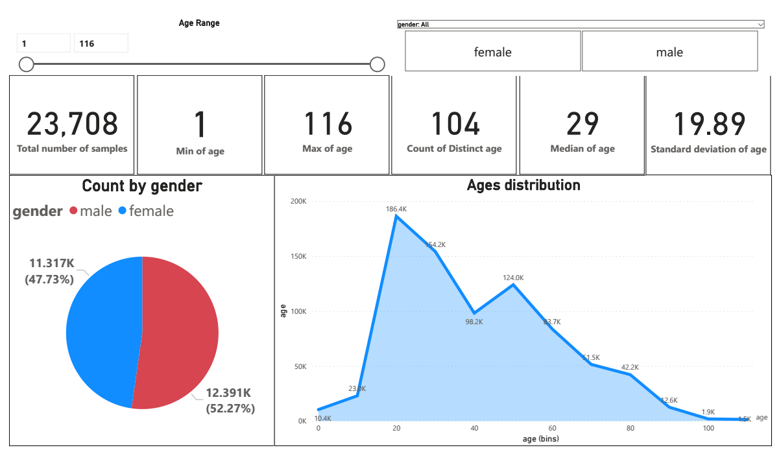UTKFace dataset is a large-scale face dataset with long age span (range from 0 to 116 years old). The dataset consists of over 20,000 face images with annotations of age, gender, and ethnicity. The images cover large variation in pose, facial expression, illumination, occlusion, resolution, etc.

1.An interactive Page from PowerBI

**IMDB:**

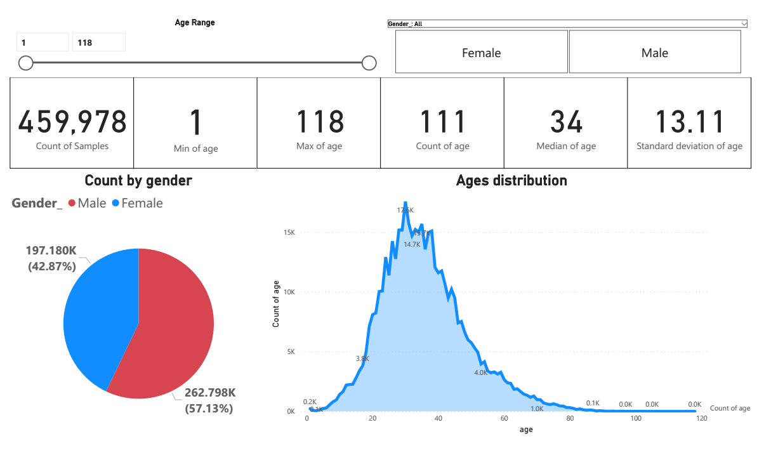IMDB dataset is a face dataset of the most popular 100,000 actors as listed on the IMDb website and (automatically) crawled from their profiles date of birth, name, gender and all images related to that person.  
Note: I have removed the outlier data, so the real total number of samples is 460,723

2.An interactive Page from PowerBI

**WIKI:**

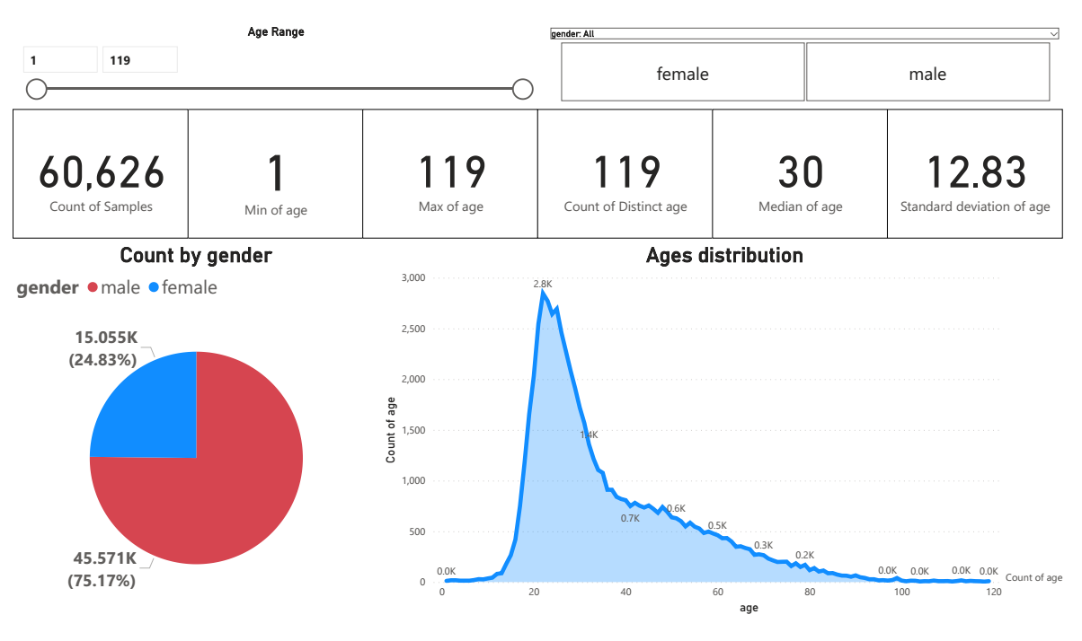WIKI dataset is a face dataset contains 62,328 images with ages from Wikipedia.  
Note: I have removed the outlier data, so the real total number of samples is 62,328

3.An interactive Page from PowerBI

**AFAD:**

The Asian Face Age Dataset (AFAD) is a new dataset proposed for evaluating the performance of age estimation, which contains more than 160K facial images and the corresponding age and gender labels. This dataset is oriented to age estimation on Asian faces 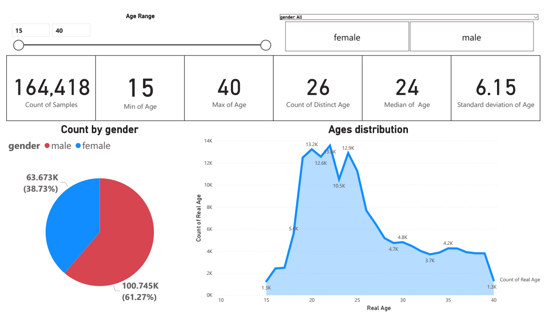

4.An interactive Page from PowerBI

**CACD:**

Cross-Age Celebrity Dataset (CACD) contains 163,446 images from 2,000 celebrities collected from the Internet.

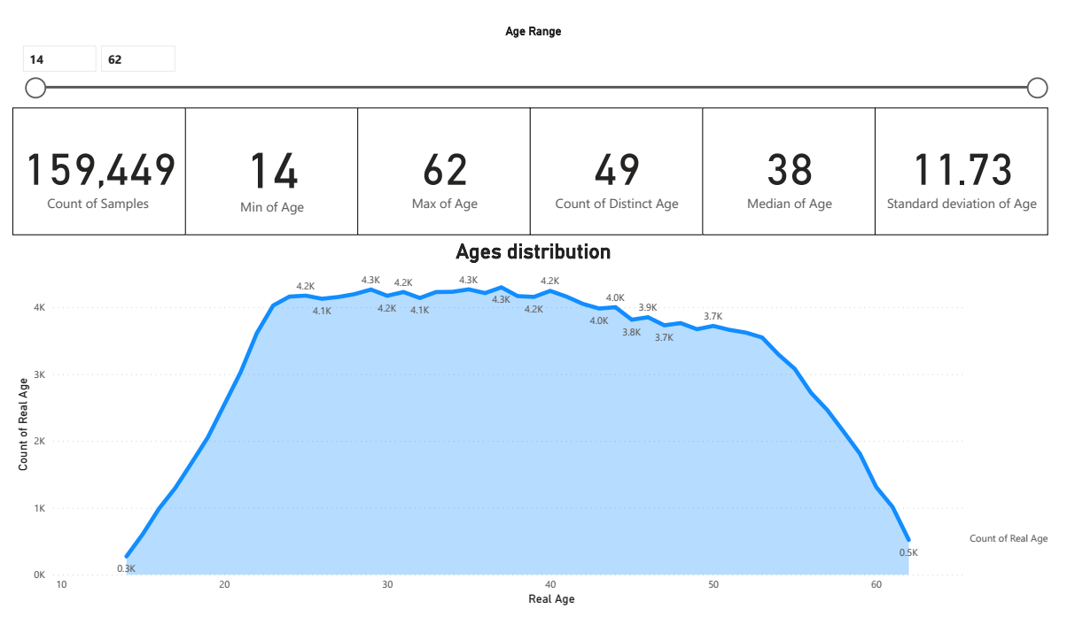Note: This Dataset doesn't have the Gender Feature

5.An interactive Page from PowerBI

**MORPH:**

The MORPH Longitudinal Database comprises two core datasets, each containing approximately 200,000 images, resulting in a total size of 400,000+ images! These datasets are further segmented into racial and gender subsets  
Note: This analysis is on a sample of the data only MORPH(2).

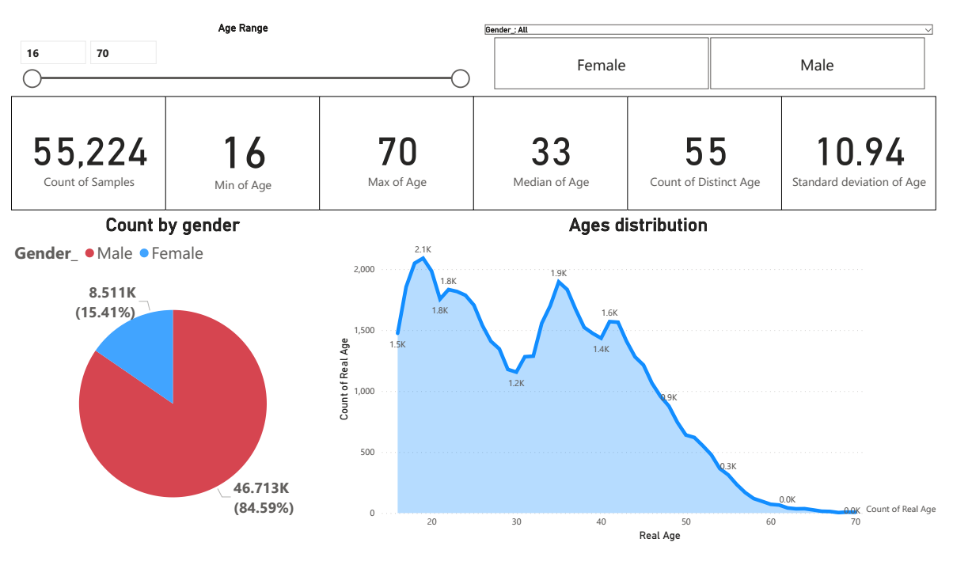

6.An interactive Page from PowerBI

**FGNET:**

FGNet is a dataset for age estimation and face recognition across ages. It is composed of a total of 1,002 images of 82 people with age range from 0 to 69 and an age gap up to 45 years.

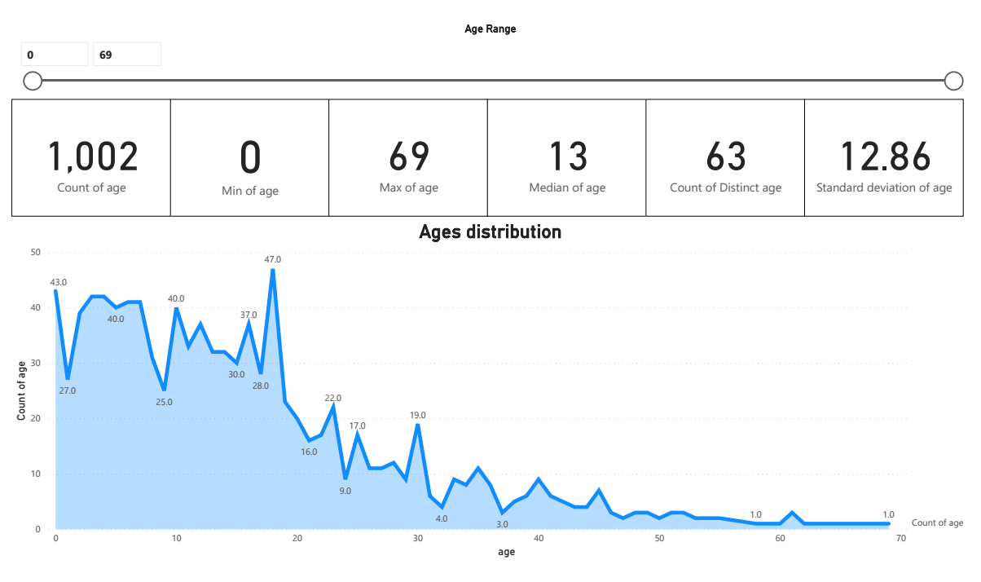Note : the original FG-NET website does not provide this data any more, but someone provide them in his homepage, this dataset don't have the Gender Feature

7.An interactive Page from PowerBI

**Adience:**

The sources of the images included in our set are Flickr albums, assembled by automatic upload from iPhone5   
(or later) smart-phone devices, and released by their authors to the general public under the Creative Commons (CC) license.   
Note: Total number of photos: 26,580 , but I have found the a metadata of this dataset have 17,452 photo only!

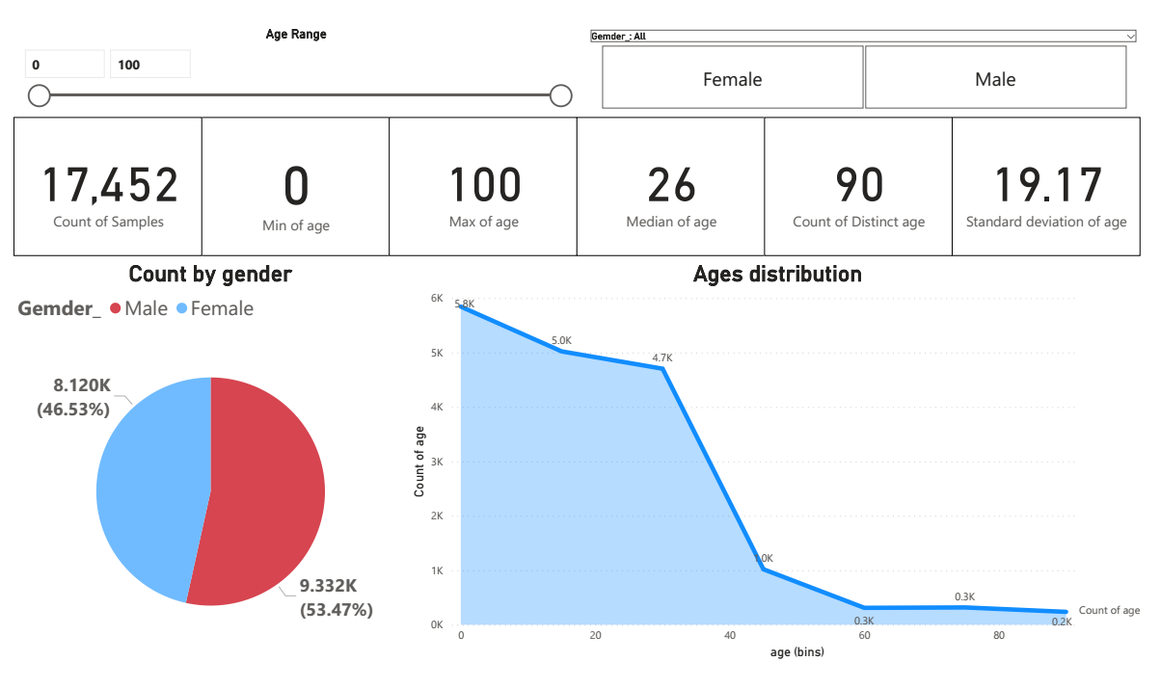

8.An interactive Page from PowerBI-

**KANFace:**

KANFace consists of 40K still images and 44K sequences (14.5M video frames in total) captured in unconstrained, real-world conditions from 1,045 subjects. The dataset is manually annotated in terms of identity, exact age, gender and kinship.

* Need need an owner contact.

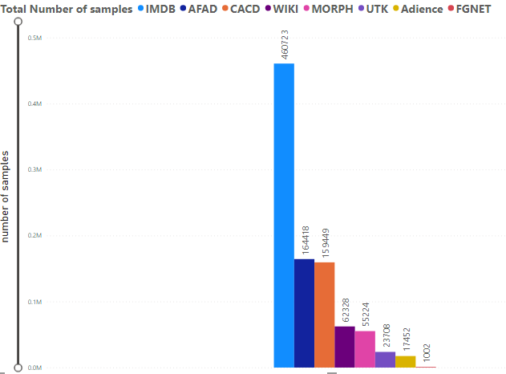**Size Comparison:**

Capturing state:

|  |  |  |
| --- | --- | --- |
| **No.** | **Dataset** | **Capturing state** |
| 1 | UTK | in the wild, provides the correspondingly aligned and cropped faces |
| 2 | IMDB | in the wild |
| 3 | WIKI | in the wild |
| 4 | AFAD | in the wild |
| 5 | CACD | in the wild |
| 6 | MORPH | Controlled |
| 7 | FGNET | in the wild |
| 8 | Adience | in the wild |
| 9 | KANFace | in the wild |

Availability:

|  |  |  |
| --- | --- | --- |
| **No.** | **Dataset** | **Availability** |
| 1 | UTK | Available |
| 2 | IMDB | Available |
| 3 | WIKI | Available |
| 4 | AFAD | Available |
| 5 | CACD | Available |
| 6 | MORPH | need an owner contact |
| 7 | FGNET | Available |
| 8 | Adience | need an owner contact |
| 9 | KANFace | need an owner contact |

Usage constraints:

|  |  |  |
| --- | --- | --- |
| **No.** | **Dataset** | **Usage constrains** |
| 1 | UTK | research purposes only |
| 2 | IMDB | research purpose only |
| 3 | WIKI | research purpose only |
| 4 | AFAD | research purpose only |
| 5 | CACD | research purpose only |
| 6 | MORPH | research use and commercial |
| 7 | FGNET | research purposes only |
| 8 | Adience | research purposes only |
| 9 | KANFace | research purposes only |

Conclusion:

* the whole datasets I have found are almost 9 if we consider imdb-wiki dataset as two separate datasets
* the imdb-wiki dataset is the most complete dataset I have found, it has large number of images, the wider range of ages, the best distribution of ages, and good equality of gender distribution.
* MORPH dataset has the largest number of images and a very good distribution based on the race, but the Gender distribution in the samples I have worked on bias toward Males.